Table 1 : Country
Code :
CREATE TABLE Country (
id INT PRIMARY KEY,
country_name VARCHAR(255),
country_name_eng VARCHAR(255),
country_code CHAR(3)
);

INSERT INTO Country (id, country_name, country_name_eng, country_code) VALUES
(1, 'Deutschland', 'Germany', 'DEU'),
(2, 'Srbija', 'Serbia', 'SRB'),
(3, 'Hrvatska', 'Croatia', 'HRV'),
(4, 'United States of America', 'United States of America', 'USA'),
(5, 'Polska', 'Poland', 'POL'),
(6, 'España', 'Spain', 'ESP'),
(7, 'Rossiya', 'Russia', 'RUS');
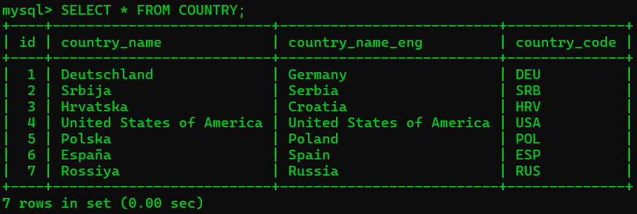

Table 2 : City
Code :
CREATE TABLE City (
id INT PRIMARY KEY,
city_name VARCHAR(255),
lat DECIMAL(10, 6),
lng DECIMAL(10, 6),
country_id INT, FOREIGN KEY (country_id) REFERENCES Country(id)
);

INSERT INTO City (id, city_name, lat, lng, country_id) VALUES
(1, 'Berlin', 52.520008, 13.404954, 1),
(2, 'Belgrade', 44.787197, 20.457273, 2),
(3, 'Zagreb', 45.815399, 15.966568, 3),
(4, 'New York', 40.730610, -73.935242, 4),
(5, 'Los Angeles', 34.052235, -118.243683, 4),
(6, 'Warsaw', 52.237049, 21.017532, 5);
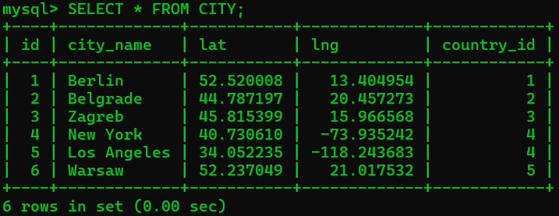

Table 3 : Customer
Code :
CREATE TABLE Customer (
id INT PRIMARY KEY,
customer_name VARCHAR(255),
city_id INT,
customer_address VARCHAR(255),
next_call_date DATE,
ts_inserted TIMESTAMP, FOREIGN KEY (city_id) REFERENCES City(id) );

INSERT INTO Customer (id, customer_name, city_id, customer_address, next_call_date, ts_inserted) VALUES
(1, 'Jewelry Store', 4, 'Long Street 120', '2020-01-21', '2020-01-09 14:01:20'),
(2, 'Bakery', 1, 'Kurfürstendamm 25', '2020-02-21', '2020-01-07 19:52:15'),
(3, 'Café', 4, 'Tauentzienstraße 44', '2020-01-21', '2020-01-10 08:02:49'),
(4, 'Restaurant', 3, 'Ulica lipa 15', '2020-01-21', '2020-01-10 09:20:21');
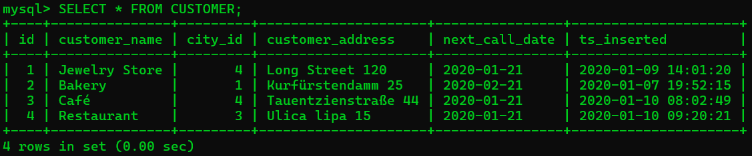

Task 1 :
Code :
SELECT
c.country_name_eng AS country_name,
ci.city_name AS city_name,
cu.customer_name AS customer_name
FROM
Country c
LEFT JOIN
City ci ON c.id = ci.country_id
LEFT JOIN
Customer cu ON ci.id = cu.city_id
ORDER BY
c.country_name_eng, ci.city_name, cu.customer_name;
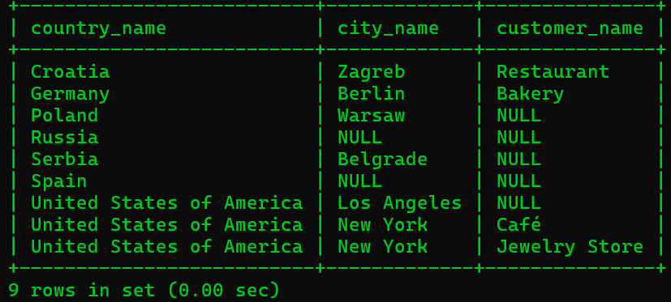

Task 2 :
Code :
SELECT
c.country_name_eng AS country_name,
ci.city_name AS city_name,
cu.customer_name AS customer_name
FROM
Country c
INNER JOIN
City ci ON c.id = ci.country_id
LEFT JOIN
Customer cu ON ci.id = cu.city_id
ORDER BY
c.country_name_eng, ci.city_name, cu.customer_name;
